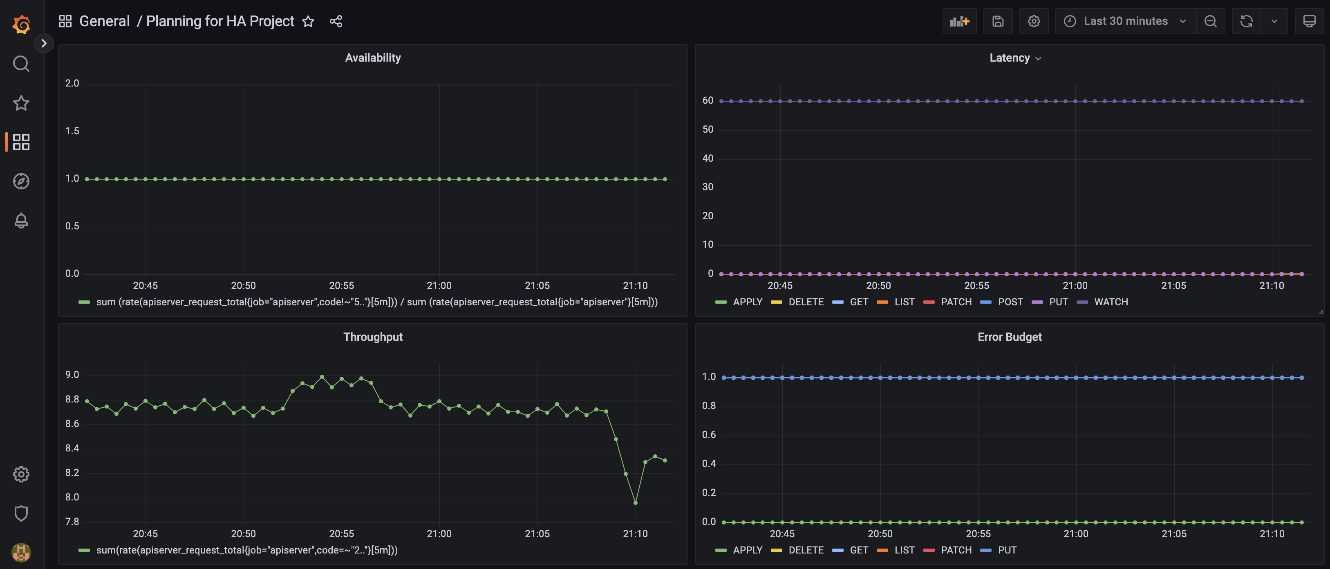

Successful Deploy to Zone 1 After Making HA

Screen Shot of ALB After Deployment

Starting Deployment To Zone2

Intitial Run Failed do to Monitoring Namespace not being present, added namespace and then ran again

Successful Completion of Deployment from Zone2

Destroying From Zone2

Successful Destroy of Zone2 Resources

Initiating Terraform Destroy for Zone1

Successful Destroy of Zone1 Resources

